**National University of Computer and Emerging sciences** 

**Objectives:**

∙ To learn and understand how to design a multiple output combinational circuit and implementation of universal gates

**Exclusive-OR & Exclusive-NOR gates:**

The figure given below shows the symbol of Exclusive-OR (XOR) and Exclusive-NOR (XNOR) gates.



XNOR gate XOR gate

Boolean expression of XNOR gate isand Boolean expression of XOR is. Boolean expression of XNOR gate can be implemented using XOR gate as shown in figure below:

**Function Table:**

| **Inputs** | | **Output** |
| --- | --- | --- |
| **A** |  | **B** |
| L |  | L |
| L |  | H |
| H |  | L |
| H |  | H |

H= Logic High, L= Logic Low

**Y**  L

H

H L

**Connection Diagram:**

**74LS86 IC** will be used for implementation of XOR gate function. **74LS86 IC** contains four 2- input XOR gates. The function table and connection diagram for this IC are shown below: 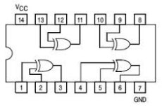

**Universal Gates**

**Introduction to NAND Gate**

74LS00 IC contains four 2-input NAND gates. The function table and connection diagram for this IC are shown below:

**Function TableConnection Diagram:**

| **Inputs** | | **Output** |
| --- | --- | --- |
| **A** |  | **B Y** |
| L | L | H |
| L | H | H |
| H |  | L H |
| H |  | H L |

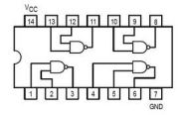

H= Logic High, L= Logic Low

**Introduction to NOR Gate**

74LS02 IC contains four 2-input NOR gates. The function table and connection diagram for this IC are shown below:

**Function Table:Connection Diagram:**

| **Inputs** | | **Output** |
| --- | --- | --- |
| **A** |  | **B Y** |
| L | L | H |
| L | H | L |
| H |  | L L |
| H |  | H L |

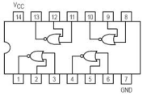

H= Logic High, L= Logic Low

**In-lab tasks:**

**Implementations on Logic Works and Logic Trainers**

**Question 1[a]: Implement the OR gate using only the NAND gates a. Z=A+B**

**Question 1[b]: Implement the AND gate using only the NOR gates a. Z=A.B**

**Question 2:**

Design a combinational circuit whose input is a 4-bit number and whose output is the 2’scomplement of the input number.

(Make truth table and optimize the circuit with K-Maps).

**Implementations on Logic Works**

**Question 3:**

**BCD - to - Seven - Segment Display**

Design a circuit which takes binary of a BCD digit and displays the digit. (Make truth table and optimize the circuit with K-Maps).

**Steps for designing a circuit on trainer:**

1- Make a Truth Table

2- Derive the optimized equations (Use k-maps)

3- Draw circuit on paper

4- Implement the circuit on Logic Trainer/Works or both